AS BIRDS FLYING

The Miracle of December the 8th, 1917

By Victor
“Surely the Lord God will do nothing, but he revealeth his secret to His servants the prophets” (Amos 3:7).
In August of 1914 the Great War broke out in Europe. General Edmund Allenby of the British Army began the war in command of a Calvary division on the Western Front. He was later promoted to command the 5th Corps of the British Expeditionary Force in Europe. In October 1915 he took command of the Third Army, which in 1916 took part in the battle of the Somme.
The War in Palestine really began in 1915, with a Turkish offensive against the Suez Canal. It was beaten back, but in late 1916 and early 1917, when the British launched a counter offensive, they were severely repulsed by the Ottoman Turks. British Prime Minister Lloyd George commented at the time, “Nobody could have saved the Turks from complete collapse, but our General Staff.” In June 1917, General Allenby was ordered to leave his Third Army and take command of the British war effort in the Middle East.
Allenby was not excited about his new assignment. General Sir Beauvoir de Lisle saw Allenby at the Grosvenor Hotel in London before the latter left for Cairo. Allenby said to him, “The last man failed, and I do not see why I should succeed.” Sir Beauvoir, who was later to preach a sermon at St. Martin’s in the Fields about the capture of Jerusalem, consoled him with Bible prophecies of the deliverance of Jerusalem. He told General Allenby that the Bible said that Jerusalem would be delivered in that very year, 1917, and by Britain.
In 1886, Dr. Grattan Guinness had written a book titled “Light for the Last Days” in which he demonstrated from the Scriptures that Jerusalem would be delivered from Turkish rule in 1917. In 1898, Dr. H. Aldersmith, another eminent student of Bible prophecy, wrote a book called “Fullness of the Nations,” in which he said that Jerusalem would be delivered by Great Britain in 1917. In personal conversations, Dr. Aldersmith would say that he believed that Jerusalem would be delivered by some sort of flying machine, although the airplane had not yet been invented.
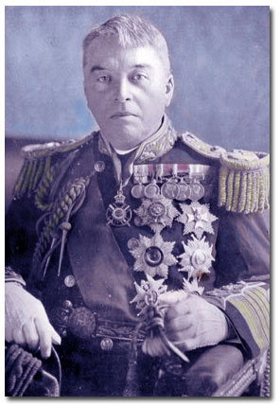
Admiral Lord Fisher
Before sailing to Cairo to take command, General Allenby was summoned to a meeting with Admiral Lord Fisher, the First Sea Lord. In one of the most extraordinary military conferences of war, recorded by Lord Fisher’s secretary, Allenby was told that he would be God’s instrument for the deliverance of Jerusalem in December 1917. Stunned by Lord Fisher’s words, he asked him to explain his deduction. Admiral Lord Fisher, First Sea Lord, then spent several hours in discussing the Bible with General Allenby, showing him the prophecies that related to the rise of Great Britain, and lastly the prophecies relating to the deliverance of Jerusalem in December 1917. Armed and strengthened by this knowledge, General Allenby sailed for the Middle East. But God’s hand was clearly in evidence. Under Allenby’s command was the famous Thomas Edward Lawrence – Lawrence of Arabia. Many books and articles have been written about the exploits of T.E. Lawrence, and continue to be written. One of the great adventure stories of English literature is “The Seven Pillars of Wisdom” by Lawrence.

Allenby was a devout Christian. He often consulted the Bible for spiritual direction, and for historical and geographical military guidance for an army fighting in Palestine; and would frequently ask his staff to bow their heads with him to pray for success in battle with few causalities. In his biography of Allenby, Field Marshal Wavell recounts a saying among the Arabs at the time, “When the waters of the Nile flow into Palestine, then will a prophet of the Lord deliver Jerusalem from the Turkish yoke.” Under Allenby the waters of the Nile did flow into Palestine via a pipeline laid by the Royal Engineers to supply the British forces. The Arabs called General Allenby “Allah eh Nebi” which means, prophet of God.
After many battles the British Army finally made its approach to Jerusalem. Allenby’s plan was to partially encircle Jerusalem, intentionally leaving a safe way of escape in hopes that the Turkish Army would withdraw, avoiding a siege of the Holy City.
When the British forces had come within striking distance of Jerusalem, and were coming under fire from Turkish batteries within the city, Allenby did not want to return fire believed that it was unworthy of Christian Britain to fire on the Holy City. He called Prime Minister Lloyd George for instructions. George replied that the Cabinet was leaving him free to do whatever he thought best. Not satisfied with such an answer, he called the King for guidance. King George 5th replied, “Pray about it.” Gathering his staff together, General Allenby followed the King’s counsel.
This takes us to the morning of Saturday December 8, 1917. The British chaplains that morning led the troops in prayer. The first lesson from Morning Prayer on that day was from Isaiah chapter 31. The very prophecy that was to be fulfilled on that day was found in that lesson in Isaiah 31:4-5:
“For thus hath the LORD spoken unto me, Like as a lion and the young lion roaring on his prey, when a multitude of shepherds is called forth against him, he will not be afraid of their voice, nor abase himself for the noise of them: so shall the LORD of hosts come down to fight for mount Zion, and for the hill thereof. As birds flying, so will the LORD of hosts defend Jerusalem; defending also He will deliver it; and in passing over He will preserve it.”
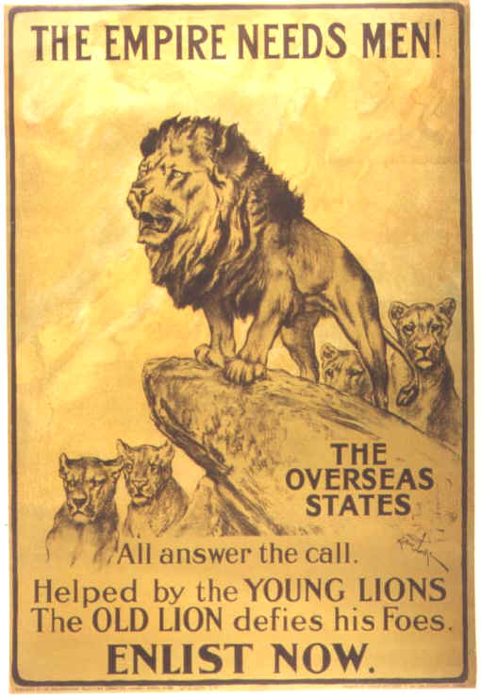
That day, December 8, 1917, was also the Feast of Hanukah, commemorating an earlier deliverance of Jerusalem by Judah Maccabee two centuries before Christ.
In the reading from Isaiah, General Allenby saw the lion in the prophecy as representing Great Britain, and the young lion his ANZAC (Australian and New Zealand) troops. When Isaiah spoke prophetically of God defending, delivering and preserving Jerusalem “as birds flying,” Allenby knew exactly what that meant.
By this time the Royal Flying Corps had complete air supremacy over Palestine. That morning General Allenby ordered British planes to make reconnaissance flights over Jerusalem and to drop leaflets calling upon the Turkish garrison to surrender, but were directed not to bomb or strafe the Holy City. With all of the British air activity, panic broke out among the garrison who had no air support to speak of, and the Turkish officers could not get the situation under control. That night Izzet Bey the governor of Jerusalem smashed all the equipment in the telegraph office, and wrote a letter of surrender. At 2:00 AM, on December 9th, the Turkish garrison began leaving through the Jaffa Gate. By 7:00 AM, the last of the Turkish soldiers were passing through St. Stephen’s Gate making their way along the Jericho Road. Bey and a few frightened policemen came out of the city bearing a white flag and surrendered Jerusalem to General O’Shea of the 60th division. The Holy City had been delivered without a shot being fired.
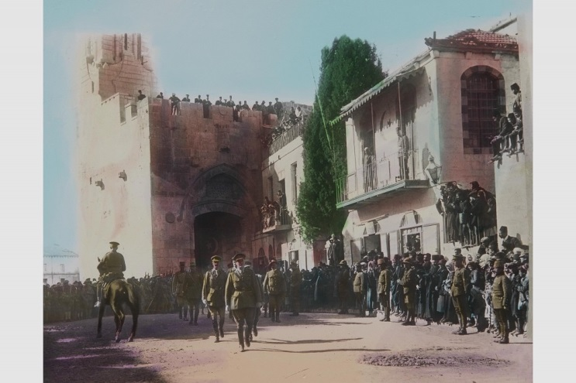
General Allenby dismounted and entered Jerusalem through the Jaffa Gate on foot out of respect for Jesus who rode in on a donkey

On December 11th, 1917, General Edmund Allenby entered Jerusalem silently on foot and without fanfare. No guns were fired in salute. Only the bells of Jerusalem’s churches rang, Isaiah 36:5 had been fulfilled, “As birds flying, so will the LORD of hosts defend Jerusalem, defending also He will deliver it, and passing over He will preserve it.” “As birds flying,” God had used the Royal Flying Corps to frighten the garrison into leaving. As foretold, God had delivered the Holy City and preserved it. There was no siege.
After the war, General Allenby was appointed British High Commissioner of Egypt, and made peer of the realm, becoming Viscount Allenby of Megiddo and Felixstowe. He died in 1936, and is buried in Westminster Abbey – a great honour for a great, noble and pious man.
But how do we arrive at the year 1917 in Bible prophecy? When making His covenant with the people of Israel, God warned them if they sinned they would be corrected, and that there would be a “seven times” punishment (Lev. 26:28) for national apostasy.
A “time” in the Bible is 360 days (Dan. 7:25, 12:7; Rev. 12:6 and 12:14). In Bible prophecy, a day often means a year, “each day for a year” (Num. 14:34; Ez. 4:6). Students of Bible prophecy call this “the Year/Day Principle.” A year of 360 days is known as a “prophetic year” as distinct from lunar or solar years.
There are seven references in the Bible which help us understand the seven times punishment of Leviticus 26:28:

Time, Times and the dividing of times (3½)  Time, times and a half (3½)  Forty and two months (3½ years)  A thousand, two hundred and three score days  A thousand, two hundred and three score days  Time, times and a half time (3½)  Forty and two months (3½ years) | Dan. 7:25  Dan. 12:7  Rev. 11:2  Rev. 11:3  Rev. 12:6  Rev. 12:14  Rev. 13:5

A “time” is a prophetic year of 360 days, and a day represents a year. The Seven Times Punishment for national apostasy was to last 2520 years.
Jesus told us that Jerusalem would be trampled down by the heathen (Gentiles) until the time of the heathen was fulfilled. Leviticus 26:28 tells us that the punishment for national apostasy was to last 2520 years. The prophesied 2520 years stretched from 604 BC to AD 1917 ( a year must be added because the calendar goes from 1 BC to AD 1 without a year zero). Christians saw this prophecy in the Bible well before it was fulfilled, and Admiral Lord Fisher, First Sea Lord, General Allenby, and many other devout Christians, were confident that this prophecy would be fulfilled to the letter. And it was.
The Seventy Weeks prophecy of Daniel 9:24-27 is interpreted using the same prophecy year/day rule, with a day representing a year. The Seventy Weeks (seventy weeks of years) prophecy begins in 457 BC with the decree of Artaxeres to restore and to build Jerusalem (Dan. 9:25). The 69th prophetic weeks ends in AD 27 with the baptism of Jesus, “until Messiah the Prince.” In the midst of the 70th week, AD 31, “shall Messiah be cut off, but not for himself.” And at the end of the 70th week, AD 34, Stephen the proto-martyr was stoned, signalling the final rejection of the Messiahship of Jesus by the Jewish authorities (Acts 7:58, 8:4) and ultimately resulting in the destruction of Jerusalem by the Romans in AD 70.
Christians argue about many things, often dividing over minor differences.
Opinions and personal preferences that cannot be proved objectively one way or other continues to absorb the attention of believers and divide Christians into often hostile camps, yet hundreds of Bible prophecies have been fulfilled to the letter and still many Christians have no interest in them, or will even doubt or dispute what I have shared with you today.
They will tell you that although everything happened just as I have described it, for history bears witness to it, yet it is merely a coincidence. They will insist that we have to believe everything that was revealed 2,000 or more years ago, while doubting or denying what God is doing all around us and the fulfilment of prophesies in our day. For many, Christianity is a religion about what happened long, long ago in a land far away, but not about what God is doing today and will do tomorrow. This “Christianity” is little more than Deism. A parishioner of mine recently told me of a Jewish friend that does not practice his faith because God hasn’t spoken to the Jewish people since the time of Malachi some 2,400 years ago. He says, “God has forgotten us.” Sadly, many Christians act as though God hasn’t had a word for them for nearly 2,000 years. But that is not true. God has not abandoned His people. He continues to speak to us through His prophets as recorded in the Holy Scriptures. We need only to study the Holy Scriptures and search it out. The miracle of December 8th, 1917, is a powerful reminder that our God will neither slumber or sleep, but that He is working out His purposes all around us.
“Surely the Lord GOD will do nothing, but He revealeth his secret unto His servants the prophets” (Amos 3:7).
“It is the glory of God to conceal a thing, but the honour of kings is to search out a matter” (Prov. 25:2).
“By measure hath He measured the times, and by number hath He numbered the times: and He doth not move nor stir them until the said measure be fulfilled” (2 Esdras 4:37).

